DA10.2021.575.1 - Conditions of Consent

Parameters

- Approved plans and supporting documentation
Development must be carried out in accordance with the following approved plans and supporting documentation (stamped by Council), except where the conditions of this consent expressly require otherwise.

Plan No. | Rev | Plan Title | Drawn by | Dated
DA1 | D | DRAWING COVER SHEET | CivilTech Consulting Engineers | February 2023
DA2 | D | SUBJECT SITE AERIAL OVERLAY | CivilTech Consulting Engineers | 10.2.2023
DA3 | D | SUBDIVISION LAYOUT PLAN | CivilTech Consulting Engineers | 10.2.2023
DA4 | D | STAGING PLAN | CivilTech Consulting Engineers | 10.2.2023
DA5 | D | BULK EARTHWORKS CUT FILL PLAN | CivilTech Consulting Engineers | 10.2.2023
DA6 | D | ROADWORKS PLAN | CivilTech Consulting Engineers | 10.2.2023
DA7 | E | STORMWATER DRAINAGE LAYOUT PLAN | CivilTech Consulting Engineers | 27.2.2023
DA8 | D | STORMWATER DRAINAGE CATCHMENT PLAN | CivilTech Consulting Engineers | 10.2.2023
DA9 | D | GRAVITY SEWER & LPS CONCEPT LAYOUT | CivilTech Consulting Engineers | 10.2.2023
DA10 | D | WATER, ELEC & COMMS SCHEMATIC CONCEPT | CivilTech Consulting Engineers | 10.2.2023
DA11 | D | N-S DRAIN REALIGNMENT PLAN AND SECTIONS | CivilTech Consulting Engineers | 10.2.2023
DA12 | D | LOCAL AREA TRAFFIC MANAGEMENT PLAN | CivilTech Consulting Engineers | 10.2.2023
DA13 | D | ROAD 1 LONG SECTION & CROSS SECTIONS | CivilTech Consulting Engineers | 10.2.2023
DA14 | F | ROAD 2 LONG SECTION - START TO CH600 | CivilTech Consulting Engineers | 27.2.2023
DA15 | E | ROAD 2 LONG SECTION - CH600 TO END | CivilTech Consulting Engineers | 26.2.2023
DA16 | D | ROAD 2 CROSS SECTIONS - START TO CH500 | CivilTech Consulting Engineers | 10.2.2023
DA17 | D | ROAD 2 CROSS SECTIONS - CH550 TO END | CivilTech Consulting Engineers | 10.2.2023
DA18 | E | ROAD 3 LONG SECTION & TYPICAL SECTION | CivilTech Consulting Engineers | 10.2.2023
DA19 | D | ROAD 3 CROSS SECTIONS | CivilTech Consulting Engineers | 10.2.2023
DA20 | E | ROAD 4 LONG SECTION & TYPICAL SECTION | CivilTech Consulting Engineers | 27.2.2023
DA21 | D | ROAD 4 CROSS SECTIONS | CivilTech Consulting Engineers | 10.2.2023
DA22 | E | ROAD 5 LONG SECTION & TYPICAL SECTION | CivilTech Consulting Engineers | 10.2.2023
DA23 | D | ROAD 5 CROSS SECTIONS | CivilTech Consulting Engineers | 10.2.2023
DA24 | F | ROAD 6 LONG SECTION & TYPICAL SECTION | CivilTech Consulting Engineers | 27.2.2023
DA25 | D | ROAD 6 CROSS SECTIONS | CivilTech Consulting Engineers | 10.2.2023
DA26 | F | ROAD 7 LONG SECTION & TYPICAL SECTION | CivilTech Consulting Engineers | 27.2.2023
DA27 | D | ROAD 7 CROSS SECTIONS | CivilTech Consulting Engineers | 10.2.2023
DA28 | D | FILTER MEDIA PROFILES & ENGINEERING DETAILS | CivilTech Consulting Engineers | 10.2.2023
DA29 | E | TYPICAL SECTIONS & HYDRAULIC CALCULATIONS | CivilTech Consulting Engineers | 27.2.2023
DA30 | A | INTERSECTION TREATMENT DETAILS & CALCS | CivilTech Consulting Engineers | 10.2.2023
DA31 | C | TYPICAL STORMWATER INFILTRATION DETAILS | CivilTech Consulting Engineers | 26.4.2023
P2008063JR01VO5 | 4 | Stormwater Management Plan: Proposed Subdivision, 15 Torakina Road, Brunswick Heads, NSW | Martens Consulting Engineers | 13.3.2023
1- 211400_05 | C | Mosquito Risk Management Plan | AWC Pty Ltd | 13/09/2022
1-211400_04 | C | Acid Sulfate Soil Management Plan | AWC Pty Ltd | 12/09/2022
1-211400_03 | B | Surface Water and Groundwater Management Plan (as amended by conditions) | AWC Pty Ltd | 14/09/2022
1-211400 | E | Wallum Froglet Management Plan (revised September 2022) | AWC Pty Ltd | 17/09/2021
1-211400 | J | Revised Vegetation Management Plan | AWC Pty Ltd | 09/11/2022
1-211400_00  To  1-211400_17 | D | Landscape Plans - Bayside Brunswick Landscape Documentation and Habitat Creation | AWC Pty Ltd | 17/12/21
In the event of any inconsistency between the approved plans and the supporting documentation, the approved plans prevail. In the event of any inconsistency between the approved plans and a condition of this consent, the condition prevails.

Note: an inconsistency occurs between an approved plan and supporting documentation or between an approved plan and a condition when it is not possible to comply with both at the relevant time.

Such plans and specifications must be submitted to the Principal Certifying Authority and shall form part of the Construction Certificate

- Staged Development
The development is to be carried out in the following stages:

Early Stage 1: ECOLOGICAL REHABILITATION WORKS TO LOT 324, 402, AND 521
Early Stage 2: BULK EARTHWORKS FOR CIVIL STAGES 1,2 AND 3
EASTERN PRECINCT EARTHWORKS & N-S- DRAIN TO BE CONSTRUCTED IN EARLY STAGE 2
Civil Stage 1: 26 LOTS (Lots 105 to 111, 114 to 121, 123 to 133) + 4 Duplex LOTS (Lots 104, 112, 113 & 122) + 3 M.D. LOTS (Lots 101 to 103)
Civil Stage 2: 20 LOTS (Lots 201, 203 to 212, 215 to 223) + 3 Duplex LOTS (Lots 202, 213 to 214)
Civil Stage 3: 28 LOTS (Lots 301 to 311, 315 to 322, 324 to 332) + 5 Duplex LOTS (Lots 312 to 314, 323 & 333)
Civil Stage 4: 14 LOTS (Lots 401 to 405, 408 to 411, 413 to 417) + 3 Duplex LOTS (406, 407 & 412)
WESTERN PRECINCT EARTHWORKS TO BE CONSTRUCTED IN CIVIL STAGE 4
Civil Stage 5: 16 LOTS (Lots 502 to 509, 512 to 519) + 4 Duplex LOTS (501, 510 to 511 & 20) + Lot 521
WESTERN PRECINCT EARTHWORKS TO BE CONSTRUCTED IN CIVIL STAGE 4 and 5
Where conditions are required to be satisfied prior to a particular event, those conditions are the conditions relevant to the works being carried out in the stage.

Stages must be commenced in the order stated above however any stage may commence prior to the completion of previous stages in the list above.

The relevant conditions are the conditions deemed necessary, by the Principal Certifying Authority (PCA) appointed for the development, or, where pursuant to the issue of a Subdivision Works Certificate, the relevant consent authority.

- Vegetation Removal
This development consent does not authorise any native tree to be ringbarked, cut down, lopped, removed, or damaged, or caused to be ringbarked, cut down, lopped, removed or damaged beyond those in the area identified as “extent of works” on the Vegetation Management Plan (VMP). No native trees or vegetation may be cleared or removed until a Subdivision Certificate has been issued relevant to those trees and vegetation.

- Discovery of Aboriginal Relics
Upon discovery of any Aboriginal relics within the meaning of the National Parks and Wildlife Act 1974, the developer shall immediately notify the NSW Department of Planning Industry and Environment (DPIE), Tweed Byron Local Aboriginal Land Council and the Bundjalung of Byron Bay Aboriginal Corporation (Arakwal) and must immediately cease works within the vicinity until such time as the necessary permits have been obtained from DPIE to continue the work. The developer must comply with any further request made by DPIE to cease work for the purposes of archaeological assessment and recording.

- Integrated Approvals from other State Government Approval Bodies
This development consent includes an Integrated development approval under Sections 4.46 and 4.47 of the Environmental Planning and Assessment Act 1979, an authorisation under section 100B of the Rural Fires Act 1997 in respect of bush fire safety for subdivision for the purpose of creating residential land, and is subject to the General Terms of Approval from the RFS dated 23 December 2021 contained in Schedule 1 of this Notice of Determination.

The following conditions will need to be complied with prior to issue of Subdivision Works Certificate – early Stage 1

- Amended Vegetation Management Plan – Early Stage 1
An amended vegetation management plan must be updated and submitted to Council for approval and include the following:

- Provide an accurate plan at 1:200 scale that clearly indicates the location of compensatory plantings for the glossy black cockatoo and the koala as indicated in the VMP as approved under Condition 1
- Provide details for the ongoing vegetation management of the mitchells rainforest snail habitat in Management Zones 1 and 4 and its long term protection

- Provision of 50 nest boxes designed for glossy black cockatoos and a range of arboreal mammals found in the area. The plan to show the location of the boxes to be installed together with details of the monitoring and reporting to Council of their use. The boxes to be installed as part of Early Stage 1. The plan to also include details of the monitoring with a 6 monthly inspection regime, and reporting of the boxes across the seven stages of the development with mitigation measures to replace boxes if damaged or utilized by pest including bees, mynas and other feral animals, termites and the like.
- include details of strategies to be used to restrict breeding opportunities for the introduced Cane Toad Rhinella marina, such as the planting of dense sedges to widths of up to 5 m along watercourses.

The plan to be prepared by a suitably qualified Ecologist.

- Amended Wallum Froglet Management Plan
An amended Wallum Froglet Management Plan to be submitted to Council for approval prior to the issue of the Subdivision works certificate. The amended WFMP must contain a review of engineering plans including Basin Layout Plans prepared by Civil Tech Ref: 1133-GW5_A (Sheet 5 of 7), and Hydrological Assessment Ref: P2008063JR02V03 prepared by Martens P/L dated 25 August 2021. In particular the amended plan is to address:
- Modelling results in terms of potential zero drawdown of groundwater levels in the retained habitat area (MZ-3A) adjacent to the proposed new stormwater drain, and a description of how such changes to hydrology and water quality/ chemistry will be managed in the context of recreating Wallum froglet habitat and the existing habitat within the existing drain.
- Illustrate on maps of a suitable scale (1:200 or better) detailed engineering plans and word form identifying the donor Wallum Froglet habitat areas which includes the vegetation suite and dimensions (H/L/D) of the individual habitat areas and overall area of the habitat earmarked for translocation.
- Detailed engineering plans indicating the location of the translocated habitat plots as indicated in Northwest Landscape Plan, Southwest Landscape Plan Central Drain Habitat & Rehabilitation Zone Plan and Eastern Habitat & Rehabilitation Zone Plan of the Revised Vegetation Management Plan (Revision J - 09/11/22)
- Prior to the translocation of any Wallum Froglet habitat from the proposed house lot area, Wallum Froglet population surveys are to be carried out before and after rainfall events at these sites to establish both population size and density of existing Wallum Froglets in the Wallum Froglet habitat areas to be moved (Fig 1.3 – Wallum Froglet Habitat Mapping – Revised Wallum Froglet Management Plan). This will be used as a benchmark to rate success of planned translocation.

- A Habitat Translocation Plan to include WF survey methodology, Wallum Froglet translocation methodology, translocation timing and timeframes with Key Performance Indicators for the seven stages of the development, benchmarking completion and success at the end of each stage and mitigation measures if KPI at the end of that stage is not met. The KPIs must reflect current WF population and density benchmarks, with reporting and monitoring to be provided to Council as required including with each Subdivision Works Certificate (from early Stage 2, Civil Stage 1 to 5) and Subdivision Certificate (from Civil Stage 1 to 5).

- Mitigation measures should the translocated habitat not survive and function as intended and how it is to be replaced over the seven stages of the development

The Management Plan to be prepared by a suitably qualified ecologist and peer reviewed by a suitably qualified hydrogeologist prior to submission to council for approval.

- Construction Environmental Management Plan
A detailed Construction Environmental Management Plan (CEMP) is to be prepared and submitted to Council. The CEMP shall document all environmental related commitments for each Stage of development including but not limited to mitigation, management, restoration, monitoring, and reporting detailed in the approved ASSMP, SMP, DMP, SWGMP, UFP, VMP, and WFMP.
The CEMP is to be developed so that it can receive new information gathered from ongoing monitoring and modelling and be adapted as necessary to accommodate any necessary design changes and /or contingency measures.

The monitoring requirements in the ASSMP, SMP, SWGMP, UFP, VMP, and WFMP shall be included the CEMP to include:
- Analysis of all monitoring and sampling data against baseline data and approved thresholds (in the approved CEMP), limits and triggers; and
- At least six (6) monthly reporting during subdivision construction works for at least five (5) years or until two years following the issue of a subdivision certificate for Stage 5, whichever is the later; and
- Reporting on the performance of the road pavement, bioretention basin, bio pods and the North South drain by the project engineer or other professional with sufficient experience and capabilities in road pavement, construction, and establishment of bioretention basins and stormwater detention systems for Council’s acceptance demonstrating compliance with the Approved Design; and
- In the event the report required by item c identifies failures, the report shall provide an alternative design that will prevent future and ongoing failures for the civil works of the subdivision; and
- Annual reporting hereafter until the final maintenance bond is returned.

The CEMP, including the independent environmental audit of compliance with the CEMP, is to be submitted to Council for approval prior to the commencement of each stage. Any non-compliance/s are to be satisfactorily addressed before commencement of the following stage.
The CEMP must specify that the successful contractor’ is to understand the interrelationships and potential conflict during construction between surface, groundwater, vegetation, acid sulphate soils, acid frog habitat and benthic invertebrates. The successful contractor is to nominate and retain a competent Environmental Manager and Environmental Consultants in hierarchy to ensure that that the CEMP is understood fully and implemented as required.
The names and contact details of the Environmental Manager are to be provided to Council and a prestart meeting must be arranged with Council Officers prior to commencement of any groundworks and must be noted in the CEMP. The CMP must be approved by Council

- Updated Surface and Groundwater Management Plan – Monitoring, Analysis, Modelling and Contingency management
Prior to issue of a subdivision works certificate for each stage, an updated Surface and Groundwater Monitoring Plan (GMP) shall be prepared and provided to Council for approval
The SWGMP (AWC, 1-211400_03b, 14/09/2022) shall be updated to include monitoring of groundwater levels and quality prior to, during and following construction of the subdivision works as they progress, including, but not limited to:
- Monitoring results of groundwater levels and quality from the commencement of Early Stage 1 works until the issue of a subdivision certificate for Stage 5 with submission of an updated report to Council prior to the issue of the subdivision works certificate for each stage of works;
- Monitoring of groundwater levels and quality at the end of each Stage;
- Monitoring of groundwater levels and quality monthly for 12 months following the issue of a subdivision certificate for stage 5; and
- Targets for groundwater quality and levels and the commitment to use these targets in required routine reporting.
- Groundwater data to be compiled and analysed and uploaded into a groundwater modelling report with updated results analysed; and
- Contingency Management to resolve any unforeseen groundwater matters.

The groundwater monitoring shall consider the specific details of the site, proposed subdivision construction works methodology and subdivision layout. The construction stage monitoring must be designed and conducted as appropriate for each stage with details to be given in the CEMP.

The Surface and Groundwater Management Plan (AWC, 1-211400_03b, 14/09/2022) provides details on baseline groundwater levels and quality and this information is to be incorporated into the Updated Surface and Groundwater Management Plan.

The Plan must be prepared by a suitably qualified hydrogeologist or equivalent professional.

- Nominated Environmental Manager
An Environmental Manager will be appointed and contact name and details provided to Council. Council will require the appointed person to provide a copy of their qualifications and curriculum vitae prior to the issue of the subdivision works certificate for each Stage including early Stage 1.

The following conditions will need to be complied with prior to issue of Subdivision Works Certificate – early Stage 2 – Bulk Earthworks for Civil Stage 1, 2 and 3

- Engineering Construction Plans
Engineering construction plans and specifications must accompany the Subdivision Works Certificate application demonstrating compliance with Council's standards for the required engineering works.

Each set of drawings must be accompanied by a Certification Report which must be signed by a suitably qualified Civil Engineer or Registered Surveyor. The Certification Report will comprise the certificate and check lists set out in Annexure DQS-A of the Northern Rivers Local Government Development & Design Manuals.

The information shown on the drawings must be logically collected on discrete sheets generally in accordance with Annexure DQS-B and the Sample Drawings of the Northern Rivers Local Government Development & Designs. The drawings are to provide for the following works :

  - Earthworks Plan
A Bulk Earthworks Plan to be prepared showing existing and finished levels relevant to this stage including sections and details for compaction

  - New North South Drain
The new north south drain design in CivilTech Consulting Engineers plan 1133-DA11 must be amended to provide the following: -
- Absolute minimum channel slope of 0.25%. This is a construction hold point with a tolerance of -0.0m.
- The vegetation inside the new north south drain must be designed to cater for the velocity within the drain.
- Provision must be made to provide safety mechanism to prevent pedestrians accessing the new drain. It is noted that the v x d product of safety has been exceeded
- Provision must be made to provide energy dissipating devices to prevent erosion downstream of the 3 x 600mm dia RCP and weir.

Note: The stormwater management plan prepared by Civiltech Engineers, and Marten & Associates did not fully demonstrate compliance to Chapter 1 of Part N of BDCP2010 due to noncompliance to the minimum channel slope specified in Northern Rivers Local Government Guidelines and AustRoads. The slope of channel of the new north south drain must be amended to encourage positive drainage to the basin outlet and to prevent water logging.

  - Existing North South Drain
Any works required by the Stormwater Maintenance Management Plan for the existing drain.

- Stormwater Maintenance Management Plan for the Existing Drain
Prior to the issue of the Subdivision Works Certificate for Early Stage 2, a Stormwater Maintenance Management Plan to be prepared and submitted to Council for approval for the existing north south drain bisecting the subject land. The plan is to be consistent with the Approved Wallum Frog Management Plan and include initial work to be completed prior to its dedication to Council and ongoing management measures post dedication to Council for a functional stormwater drain. The plan to be prepared and signed off by a suitably qualified ecologist and stormwater engineer prior to submission to Council for approval.

- Imported Fill Material
Prior to the issue of a Subdivision Works Certificate, the type of fill material to be used is to be nominated by a suitably qualified geotechnical engineer. The fill is to be provided with certification that it is clean, uncontaminated, and suitable for use as engineering fill.

The nominated fill for swales or other areas that rely on infiltration is to be provided to the Certifying Authority for approval showing that the parameters of the fill meet the minimum in filtration rates as required by the Stormwater Management Plan.

Fill sources are to be nominated and must ensure consistency in the materials being used.

- Erosion and Sedimentation Control Plan
The plans and specifications to accompany the Subdivision Works Certificate application are to include a sediment and erosion control plan to indicate the measures to be employed to control erosion and loss of sediment from the site. The sediment and erosion control plan is to be designed in accordance with the requirements of the NSW Department of Housing Manual (1989), Managing Urban Stormwater, Soils and Construction.

A suitably experienced person must prepare the sediment and erosion control plan. Suitably experienced people include those certified by:

  - The Institution of Engineers, Australia, for engineering and hydrology matters.
  - The International Erosion Control Association for soil conservation matters.
  - The Australian Society of Soil Science for collection or analysis of soil data.

The plan must incorporate (without being limited to) information on general site management, material handling practices, soil stabilisation, water control, sediment control, wind erosion control and access measures.

- Retained Trees to be protected
All trees to be retained in accordance with this development consent must be illustrated on all relevant Construction Plans, along with their Tree Protection Zones formulated in accordance with AS 4970-2009 – Protection of Trees on Development Sites including exclusion fencing. The fence must:
- Be located outside the dripline of the tree so as to minimise disturbance to tree roots;
- have a minimum height of 1.8 metres;
- be constructed of wire mesh panels, plywood, steel star pickets or similar, with a maximum distance of 2metres between star pickets;
- have a minimum of 3 strands of steel wire or similar;
- have high visibility barrier mesh (eg orange), shade cloth or similar, attached to the outside of the fence and continuing around its perimeter;
- include at least one Tree Protection Zone (TPZ) sign in accordance with Section 4.4 of AS4970-2009.

Activities that are excluded within the TPZ (as per section 4.2 of AS4970-2009) include excavation, construction activity, grade changes, surface treatment and storage of material. If these activities are required within the TPZ they may only occur under the supervision of the project arborist (minimum AQF level 5 qualified arborist).

The Tree Protection Zone (TPZ) exclusion fence is to be maintained for the duration of the site clearing, preparation, construction, and landscaping works.

- Water Management Act 2000
A controlled activity approval (Section 91) under the Water Management Act 2000 is required to be obtained for the proposed works within and adjacent to existing watercourses and for the interference to an aquifer in terms of lowering groundwater levels. A copy of the approval to be submitted to the Principal Certifying Authority prior to issue of the Subdivision Works Certificate. In the event no such approval is not required written confirmation to be provided from the relevant NSW State government regulator and submitted to the Certifier instead.

- Noise and Vibration Management Plan required
A Noise and Vibration Management Plan must be submitted to Council for approval prior to the issue of the construction certificate for building works. The Noise and Vibration Plan must be prepared by a duly qualified professional and detail the methods that will be implemented for the whole project to minimise construction noise and vibration. Information should include:
- Identification of the specific activities likely to generate noise or vibration impacts.
- Identification of nearby residences and other sensitive land uses.
- Identification of all potentially affected sensitive receivers.
- Assessment of expected noise and vibration from the construction activities that are likely to affect their amenity or cause structural damage through vibration.
- Detailed examination of feasible and reasonable work practices that will be implemented to minimise noise impacts.
- Noise and vibration monitoring, reporting and response procedures.
- Strategies to promptly deal with and address noise complaints.
- Description of specific mitigation treatments, management methods and procedures that will be implemented to control noise and vibration during construction.
- Details of performance evaluating procedures (for example, noise monitoring or checking work practices and equipment).
- Procedures for notifying nearby residents of forthcoming works that are likely to produce noise impacts.
- Reference to relevant consent conditions.
- Name and qualifications of person who prepared the report.
- Nomination of an appropriate responsible person with appropriate qualifications and experience to implement and manage noise and vibration matters arising from the construction phase of the development. The responsible person must be available to receive neighbourhood inquiries and complaints at any time while work is proceeding and must record monitoring levels and response actions when exceedances or complaints occur.
- Contingency plans to be implemented in the event of non-compliance and/or complaints.

Advisory note: Refer to DECC’s ‘Interim Construction Noise Guideline’ (2009) for more information (see http://www.environment.nsw.gov.au/noise/constructnoise.htm)

- Cultural Heritage Site Inspection Plan
A Cultural Heritage Site Inspection Plan to be prepared and approved by Council prior to the issue of the subdivision works certificate incorporating site inspection protocols for officers from the Tweed Byron Aboriginal Land Council and or the Arakwal Corporation to be engaged for the Early Stage 2 Bulk Earthworks and Civil Stages 1 to 5 to monitor the site in relation to the protection of Aboriginal Cultural items and objects that may be disturbed during the construction of the development. The plan to be prepared by a suitably qualified archaeologist and is to include a letter of support or certification from the Land Council or the Arakwal Corporation.

- Unexpected Findings Protocol - Contamination & Remediation
An Unexpected Findings Protocol (UFP) shall be prepared and submitted to Council for approval prior to the issue of the Subdivision Works Certificate for the Bulk earthworks stage. The UFP shall be prepared by a suitably qualified person experienced in matters relating to Contamination of Land and Remediation.

- Planning Agreement to be entered into
The planning agreement dated 16 February 2023 between Byron Shire Council and Bayside Brunswick Pty Ltd shall be entered into prior to the issue of a subdivision works certificate.

- Mosquito Management
Documentary evidence from a suitably qualified professional is to be submitted with the Subdivision Works Certificate application demonstrating that subdivision development incorporates design measures to limit the habitat for mosquitoes in accordance with the approved Mosquito Risk Management Plan.

- Vegetation Management Plan – Completion of Establishment Works
Certification by a suitably qualified ecologist to be provided to Council demonstrating that all establishment works required for phase 1 in Management Zones

- Wallum Froglet Management
Certification by a suitably qualified ecologist to be provided to Council that the mitigation actions for stage 1 as set out in table 5.1 of the Wallum Froglet Management Plan have been met for early stage 1 prior to the Subdivision Works Certificate for Bulk earthworks has been released.

- Detailed Acid Sulfate Soil Report
A detailed acid sulfate soils assessment has been prepared and provided to Council that considers best practice management during interception and discharge of groundwater during groundworks within the north south drain including disturbance and possible oxidisation of acid sulfate soils and water.

The ASSMP must be informed by the results of additional deeper soil sampling taken to 2.8m bngl along the drain and from within basin footprints, and in areas where excavations are at or below 1.8m bngl. A minimum of six additional deep samples are to be excavated evenly along the extent of the drain. A further four samples are required at deep excavation points including sewerage station pump-well locations. Soil analysis must be undertaken by a NATA accredited laboratory as required by ASSMAC, 1998.

Investigations and reporting must provide the methodology that will be used to prevent adverse impacts prior to discharging treated groundwater into the Everett and Simpson Creeks and how reuse of soils (including pH control, etc) are managed to protect the receiving surrounding (wallum frog) environment. Information must include but not be limited to management of TSS, oxidisation of iron, acid leachate and sediment controls.

The results of the investigation must be used to prepare a Construction Environmental Management Plan. Investigations must have regard to relevant reporting standards and prepared by a suitably qualified environmental scientist and ecologist for approval by Council.

- Acid Sulfate Soil and Water Management Plan
An acid sulfate soil and water management plan must be prepared that provides specific detail on the practical management of the acid sulfate risks for this Stage and Civil stages 1-5 The ASSWMP must develop the strategy outlined in the detailed acid sulfate report and provide the following specific details (which may not be limited to):
  - Investigation and reporting for the ASSWMP must be undertaken by a suitably qualified environmental scientist.
  - The ASSWMP must have regard for the findings of additional samples being no less than ten (10) samples required by Council and conditions imposed upon this consent.
  - The location and address of all land, or portions of land, proposed to be used for ASS and PASS treatment.
  - A site plan, to an appropriate scale, shall detail the exact location of all treatment, chemical storage and transport affected parts within the boundaries of each property.
  - Details should include private owner consent and an assessment of the environmental risks and requirements under the Environmental Planning and Assessment Act 1979 where the use of such land for the treatment of contaminated soil may require separate development consent.
  - A ‘designated responsible’ person nominated as the Environmental Manager shall be accountable for managing, monitoring, and reporting on the ASS and PASS remediation program associated with this development.
  - Contact details and appropriate qualifications and professional indemnity insurance to be included.
  - The specifics of all operator training, monitoring, testing and recording to be carried out during the ASS and PASS remediation program.
  - An emergency management plan that includes all likely eventualities where ASS and PASS soil, alkaline chemicals or other environmentally harmful substances may be washed, blown or otherwise escape from the excavation site, transport vehicle or treatment containment areas.
  - The specifics of the final soil monitoring criteria, final waste classification and proposed final point of disposal of soil excavated from the subject property.
  - Works involving excavations at or below the natural ground surface must not commence until the ASSWMP has been prepared and approved by Council.
  - Remediation and management of ASS and PASS must be in accordance with the Acid Sulfate Soil Manual (NSW ASSMAC 1998) and best practice methodologies.
  - Remediation and emergency contingencies responses for incidents occurring in particular in the event of non-compliance that has potential to affect the receiving environment beyond the drain excavation including the potential Everitt’s and Simpson Creek receiving environments and native wallum frogs and their habitats.

- Dewatering Management Plan
A detailed dewatering management plan must be prepared for the installations of infrastructure that is likely to intercept the water table for this stage and subsequent Civil Stage 1-5 . The DMP must demonstrate that the methodology and equipment to be employed to undertake dewatering operations conforms with the strict environmental controls and practices required by conditions imposed upon this consent for environmental management of the site. The plan must include (but not be limited to) the following:
- Copy of licence from the Water NSW for the dewatering of excavations, including any lowering of the water table/ interference with aquifers by way of open drain construction and any associated groundwater monitoring as required.
- Legal point of discharge and method of conveying treated waters to the legal point of discharge.
- Identification of all potentially affected sensitive receivers and environments.
- Measures for the protection of the surrounding environment and receiving waters (including wallum froglet compensatory habitat areas), water quality management, litter control, Water quality criteria for waters to be discharged to the stormwater system, to be derived from ANZECC / ARMCANZ (2000) Fresh and Marine Water Quality Guidelines 95% species protection trigger levels for freshwaters, or similar. Parameters to include, but not be limited to, pH, electrical conductivity, dissolved oxygen, total suspended solids, turbidity, ammonia, oxidised nitrogen (NOx), Total Nitrogen (TN), Filterable Reactive Phosphorus, Total Phosphorus, Total Petroleum Hydrocarbons, Benzene, toluene, ethyl benzene, xylene (BTEX), Polycyclic Aromatic Hydrocarbons (PAHs) and Aluminium.
- Details of proposed water treatment prior to discharge to ensure compliance with the above water quality criteria, including those that are manual and automated.
- Site plan that demonstrates the location of all dewatering equipment and tanks.
- Details of water sampling methodologies and frequencies for each parameter.
- Details of methods to manage noise and odour impacts to nearby receivers.
- Details of disposal methods and contingency plan if water does not comply with above criteria.
- Details of a 24-hour contact person and telephone number for complaints.

The following conditions will need to be complied with prior to issue of Subdivision Works Certificate – Stage 1, 2, 3, 4 and 5 – Civil Works

Note: Individual Subdivision Works Certificates to be submitted for each stage are to be submitted.

- Controlled Activity Approval – Footpath works adjacent to the waterway area
A Controlled Activity Approval under section 92 of the Water Management Act 2000 must be made to the Natural Resources Access Regulator (NRAR) for footpath works adjacent to the waterway area. Alternatively the developer may provide documentary evidence from the regulator that such an approval is not required.

Note: The controlled activity approval may be triggered by the footpath works extending to Simpson Creek.

- Works in a Public Road Reserve
Consent under the Roads Act 1993 must be obtained for all works within public road reserves. Local Traffic Committee approval must be obtained for all regulatory signs, facilities and markings.

- Groundwater interaction with road pavement
Prior to the issue of Subdivision Works Certificates for each stage, all proposed road pavement works within that stage are to be shown to be above the level of the groundwater under the road. This reporting is to be undertaken by a suitably qualified engineer and hydrogeologist. The detailed design of each stage of works is to include any required protection measures for the pavement layers from groundwater effects.

This information is to be provided in the updated Groundwater Management Plan as required by condition 10.

- Engineering Construction Plans
Engineering construction plans and specifications must accompany the Subdivision Works Certificate application demonstrating compliance with Council's standards for the required engineering works pertinent to each Civil Stage.

Each set of drawings must be accompanied by a Certification Report which must be signed by a suitably qualified Civil Engineer or Registered Surveyor. The Certification Report will comprise the certificate and check lists set out in Annexure DQS-A of the Northern Rivers Local Government Development & Design Manuals.

The information shown on the drawings must be logically collected on discrete sheets generally in accordance with Annexure DQS-B and the Sample Drawings of the Northern Rivers Local Government Development & Designs. The drawings are to provide for the following works :

  - Works at the Intersection of Tweed St and Bayside Way (Civil Stage 1)
- Formalisation of the left side on exit stand-up kerbing
- Construction of raised concrete median 1.2m wide (necessitating the requirement for street lighting-see below)
- Installation of 'Stop' Control (converted from 'Give Way') and
- Installation of street lighting at intersection.

  - Full Width Road Construction
- Full width road and drainage construction for all proposed roads on the approved plan.
- The extended detention depth of the bioretention swales within the road reserve must cater for a 15minute duration for minor events.
- Subsoil drainage to downslope side of one-way crossfall roads in accordance with Section D4.05 of Chapter D4 in Northern Rivers Local Government Design and Construction Guidelines.
- A 1D model (e.g. HECRAS, Tuflow or other industry standard computer simulation software) is to be provided to demonstrate compliance to the following
- v x D safety criteria
- maximum gutter flow width ≤ 2.8m nor over-top the kerb during a minor event except for one-way crossfall roads and causeways
- maximum depth @ the invert of 0.15m during a major event except for one-way crossfall roads and causeways

  - Road 1 & Road 2 Intersection
Road 1 and Road 2 intersection to be constructed with a dish crossing in accordance with the approved plans.

  - Intersections of perimeter and non-perimeter road
Concrete causeways are to be provided at the intersection of road 2 west and all non-perimeter roads in accordance with the approved plans. The v x D safety requirement must be no greater than 0.4.

  - Footpath Construction and Ramps
A 1.2-metre-wide concrete footpath in accordance with the approved plans and ramps are designed in accordance with Council’s standard drawing. Ramps are to be offset 6.0m away from intersections.

  - Bus Route and Bus Stops
- Road 1, Road 2 and Road 6 are to be designed to cater for a standard unit bus.
- Intersections along bus routes are to be designed in accordance with Section D1.17 of Chapter D1 of Northern Rivers Local Government Guidelines
- Provision must be made to provide bus stops (no shelter) in accordance with Section D1.21 of Chapter D1 of Northern Rivers Local Government Guidelines

  - Bollards in lieu of 700dia Rock in Road 2 (Start to CH 385, CH 410 to CH 575 and CH 585 to CH 870), Road 6 (CH 20 to CH 150, CH 155 to CH 310 and CH 370 to CH 430) and Road 7
The proposed 700 dia Rock every 5m in CivilTech drawing 14, 15, 24 and 26 to be replaced with bollards.

  - Carparking at the southeast corner of Road 2
Carparking must be designed to cater for user Class 1 and User Class 4 in AS2890.1:2004 and AS2890.6:2009.

  - Footpath at the southeast corner of Road 2
A 1.5m wide concrete foot path with edge strips in accordance with the approved plans. Shared path is to be designed in accordance with Chapter D9 of Northern Rivers Local Government Guidelines to cater for people with disability.

  - Shared Path Connecting Road 7 and Road 2
A 2.5m wide concrete shared path with edge strips and 2.5m pedestrian bridge in accordance with the approved plans. Shared path is to be designed in accordance with Chapter D9 of Northern Rivers Local Government Guidelines to cater for people with disability.

  - Road pavement design
The road pavement is to be designed to suit minimum design equivalent standard axles (ESA) as per below:
- Road 01, Road 2 & Road 6 - 1 x 10⁶ ESA.
- All other roads - 3 x 10⁵ ESA

  - Local Area Traffic Management Devices (LATM)
LATM to be provided in accordance with the approved plans and AUSTROADS Guide to Road Design.

  - Tree Bio Pods and roof water connection
- Minimum of 1 x tree bio pod to be provided for single residential lot
- Minimum of 1 x tree bio pod to be provided to each road frontage for duplex lot
- A duplex lot adjacent to one-way crossfall roads are to be provided with dispersion trench and a bio pod.
- Minimum of 3 x tree bio pod to be provided to each road frontage for medium density lot
- Medium density lots adjacent to one-way crossfall roads are to be provided with dispersion trenches and a bio pod.
- Tree bio pods in the approved plans are to extend to all lots adjacent to Road 6 & Road 7. Refer to Civiltech Plan 1133-DA7 and 1133-DA31

  - Bioretention Basin
- Minimum 0.3m Extended detention depth
- Minimum 0.4m Filter Media consisting of loamy sand
- Minimum 0.1m constant depth of Transition Layer
- Minimum 0.2m constant depth of Drainage Layer
- Minimum 0.3m constant depth between the bottom of the transition layer and post development groundwater level
- Bioretention basin outlets pipe draining into the new north south drain must be provided with a non-return device to prevent water from entering the bioretention basin system
- Underdrains draining into the new north south drain must be provided with a non-return device to prevent water from entering the bioretention basin system
- Bioretention media specification shall be in accordance with the Facility for Advancing Biofiltration "Guidelines for Soil Filter Media in Bioretention Systems".
- Bioretention hydraulic conductivity shall be in accordance with the Facility for Advancing Biofiltration 'Practice Note 1: In Situ Measurement of Hydraulic Conductivity". The number of samples to be tested shall be in accordance with the "Water Sensitive Urban Design Construction and Establishment Guidelines - Swales, Bioretention Systems and Wetlands (Water by Design).
- Impervious liner subject to soil testing requirements in accordance with the "Water Sensitive Urban Design Technical Design Guidelines" (Water by Design).
- Basin finished surface level is top of filter media. Surface to be mulched and planted with effective nutrient removal plant with sufficient density per square meter (Lomandra and sedges at minimum 8-10 plants per m²)
- Provision of type 2 and type 4 bioretention basin in accordance with Water By Design Music Modelling Guidelines and Civiltech Consulting Engineers Plan 1133-DA7.
- Provision of a completed Bioretention Design Check & Summary in accordance with Table 22 of Water by Design Bioretention Technical Design Guidelines
- Bioretention basin construction and maintenance management plan must be prepared and submitted for approval to Council. The construction and maintenance plan include must be prepared for the following: -
- During Construction Stage
- During the Establishment Stage
- After Completion
Refer to Healthy Waterways WSUD Technical Guidelines and Water by Design Bioretention Basin Technical Guidelines and/or Water by Design Construction & Establishment Guidelines
- Hold Points of the Stormwater Quality Improvement Devices in accordance with Form A to Form A, B C, D, and E by Water by Design Construction & Establishment Guidelines

  - Streetlighting
Designed in accordance with AS1158 and Chapter D1 of Northern Rivers Local Government Guidelines laid in strict accordance with the service authorities’ requirements and accordance with the approved plans.

  - Service Conduits
Service conduits to each of the proposed new allotments laid in strict accordance with the service authorities’ requirements and in accordance with the approved plans.

  - Street Name Signs
Street name signs and posts to all proposed new roads.

  - Stripping and Stockpiling
Stripping and stockpiling of existing topsoil on site, prior to commencement of earthworks, and the subsequent re-spreading of this material together with a sufficient quantity of imported topsoil so as to provide a minimum thickness of 80mm over the allotments and footpaths and public reserves, upon completion of the development works.

  - Stormwater Drainage
Stormwater is to be collected and discharged in accordance with Council’s standards, currently Northern Rivers Local Government Development Design & Construction Manuals. A full and detailed stormwater management plan for the site must be provided for Council's records at the time of lodging detailed engineering plans for Subdivision Works Certificate approval. The drawings and management plan must be accompanied by a Design Submission Checklist as set out in APPENDIX C of the Northern Rivers Local Government Handbook of Stormwater Drainage Design, which must be signed by a suitably qualified Civil Engineer or Registered Surveyor. The drawings and management plan are to include, but not be limited to, the following items:
  - Catchment plan (included in the drawing set);
  - Hydrological and hydraulic calculations based on the methods outlined in the Queensland Urban Design Manual (QUDM) and Australian Rainfall & Runoff (AR&R) 1987. A summary of the calculations must be included on the drawings consistent with the Sample Drawings of the Northern Rivers Local Government Development & Design Manuals.
  - Stormwater detention/retention, designed so that the peak flow from the proposed development for the 5, 10, 20, 50 and 100 year ARI events, for durations from 5 minutes to 3 hours, does not exceed the existing peak flow from the site i.e. post-development flows must not exceed pre-development flows.
  - Stormwater management structures/facilities that have minimum impact on Council’s maintenance program. All maintenance activities must be specified in a maintenance plan (and associated maintenance inspection forms) to be developed as part of the design procedure and included in the stormwater management plan.

  - Stormwater Quality
Stormwater quality must be suitable for discharge in accordance with Council's standards, currently Chapter B3 Services of Development Control Plan 2014 and Northern Rivers Local Government Development Design & Construction Manuals. The proposed water quality management devices and treatment train must have minimum impact on Council’s maintenance program. All maintenance activities must be specified in a maintenance plan (and associated maintenance inspection forms) to be developed as part of the design procedure and submitted with the Subdivision Works Certificate documentation.

  - Access to Stormwater Structures
Satisfactory access to all drainage discharge points and filter controls for maintenance purposes.

- Sewerage and Water Mains
An approval is to be obtained under Section 68 of the Local Government Act 1993 to carry out water supply and sewerage works.

Sewerage and water mains are to be extended to service all residential allotments in the subdivision. All Council gravity sewerage mains are to be a minimum 150 mm diameter and water mains are a minimum 100mm diameter.

Water supply and sewerage works are to comply with Council's latest Standards and Policies including but not limited to:
  - Development Design and Construction Manuals, Northern Rivers Local Government;
  - Development Servicing Plan for Water Supply Services, Byron Shire Council;
  - Development Servicing Plan for Sewerage Services, Byron Shire Council;
  - Fire Flow Design Guidelines, Water Directorate;
  - Water and Sewer Equivalent Tenement Policy, Byron Shire Council;
  - Pressure Sewerage Policy, Byron Shire Council.
  - Private Sewer Pump Station Policy, Byron Shire Council.

- Erosion and Sedimentation Control Plan
The plans and specifications to accompany the Subdivision Works Certificate application are to include a sediment and erosion control plan to indicate the measures to be employed to control erosion and loss of sediment from the site. The sediment and erosion control plan is to be designed in accordance with the requirements of the NSW Department of Housing Manual (1989), Managing Urban Stormwater, Soils and Construction.

A suitably experienced person must prepare the sediment and erosion control plan. Suitably experienced people include those certified by:

  - The Institution of Engineers, Australia, for engineering and hydrology matters.
  - The International Erosion Control Association for soil conservation matters.
  - The Australian Society of Soil Science for collection or analysis of soil data.

The plan must incorporate (without being limited to) information on general site management, material handling practices, soil stabilisation, water control, sediment control, wind erosion control and access measures.

- Traffic Guidance Scheme (TGS)
The plans and specifications to accompany the Subdivision Works Certificate application are to include a traffic guidance scheme (TGS) to indicate the measures to be employed to control traffic during construction of the subdivision. The TGS is to be designed in accordance with the requirements of the current version of the Transport for NSW Traffic Control at Work Sites Technical Manual.

The plan shall incorporate measures to ensure that motorists using road adjacent to the development, residents and pedestrians in the vicinity of the development are subjected to minimal time delays due to construction on the site or adjacent to the site.

The TGS must be prepared by a suitably qualified Transport for NSW accredited person.

- Long Service Levy to be paid
In accordance with Section 6.14 of the Environmental Planning and Assessment Act 1979 (as amended), a Subdivision Works Certificate shall NOT be issued until any Long Service Levy payable under Section 34 of the Building and Construction Industry Long Service Payments Act, 1986 (or where such levy is payable by instalments, the first instalment of the levy) has been paid.

These payments can be made online at www.longservice.nsw.gov.au. Proof of payment is required to be submitted with the Subdivision Works Certificate application.

For further information regarding the Long Service Payment please refer to the website above.

- Compliance with bushfire conditions under Section 100B of Rural Fires Act 1997
Documentary evidence from a suitably qualified professional is to be submitted with the Subdivision Works Certificate application, demonstrating that the bushfire conditions as issued under Section 100B of the Rural Fires Act 1997 have been complied with in relation to any necessary subdivision works.

- Mosquito Management
Documentary evidence from a suitably qualified professional is to be submitted with the Subdivision Works Certificate application demonstrating that subdivision development incorporates design measures to limit the habitat for mosquitoes in accordance with the approved Mosquito Risk Management Plan.

- Street Name Application to be lodged
Street / road names for the subdivision must be submitted for Council approval prior to issue of the Subdivision Works Certificate for Civil Stage 1-5.

An application for approval of a street name must be in writing (letter or email) and is to include:
- at least 2 names for each proposed road in preferential order;
- the location and extent of the road;
- background/history of the selected name/s;
- details on why the selected name is considered to be appropriate;
- details on how the selected name conforms with Council’s Street Name Policy and the NSW Address Policy;
- a locality plan;
- a layout plan showing proposed road/s and selected name/s suitable for publishing in the local newspaper; and
- payment of fees in accordance with Council’s adopted schedule of fees and charges.

- Fibre-ready Facilities and Telecommunications Infrastructure
Prior to the issue of the Subdivision Works Certificate, the developer (whether or not a constitutional corporation) is to provide evidence satisfactory to the Certifying Authority that arrangements have been made for:
      - the installation of fibre-ready facilities to all individual lots and/or premises in a real estate development project so as to enable fibre to be readily connected to any premises that is being or may be constructed on those lots. Demonstrate that the carrier has confirmed in writing that they are satisfied that the fibre ready facilities are fit for purpose; and
      - the provision of fixed-line telecommunications infrastructure in the fibre-ready facilities to all individual lots and/or premises in a real estate development project demonstrated through an agreement with a carrier.
(Note real estate development project has the meanings given in section 372Q of the Telecommunications Act).

- Detailed landscaping plan required
Prior to the issue of a Subdivision Works Certificate for each Stage, a detailed landscaping plan must be submitted and approved by Council. The detailed plan must include all landscaping within the site. The landscaping plan must incorporate adequate detail to demonstrate compliance with the provisions of Chapter B9 of Development Control Plan 2014.

The plan must not include species that represent translocation of native plants outside their geographic range, potential or known environmental weeds or species with potential for genetic pollution. The landscaping plan must indicate:
- proposed location for planted shrubs and trees
- botanical name of shrubs and trees to be planted
- mature height of trees to be planted
- location of grassed and paved areas, and
- location of trees identified for retention in the development application plans and any required

Tree Protection Zones measured in accordance with AS 4970-2009 – Protection of Trees on Development Sites.

The plan is to be prepared by a suitably qualified landscape architect or ecologist who has appropriate experience and competence in landscaping.

- Imported Fill Material
Prior to the issue of a Subdivision Works Certificate for each stage, the type of fill material to be used is to be nominated by a suitably qualified geotechnical engineer. The fill is to be provided with certification that it is clean, uncontaminated, and suitable for use as engineering fill.

The nominated fill for swales or other areas that rely on infiltration is to be provided to the Certifying Authority for approval showing that the parameters of the fill meet the minimum in filtration rates as required by the Stormwater Management Plan.

Fill sources are to be nominated and must ensure consistency in the materials being used.

- Site Waste Minimisation and Management Plan
Chapter B8 of Byron Shire Development Control Plan 2014 (DCP 2014) aims to facilitate sustainable waste management in a manner consistent with the principles of Ecologically Sustainable Development. Prior to the issue of a Construction Certificate, a Site Waste Minimisation and Management Plan (SWMMP) must be submitted outlining measures to minimise and manage waste generated during demolition, construction and the ongoing operation and use of the development. The SWMMP must specify the proposed method of recycling or disposal and the waste management service provider.
A template is provided on Council’s website to assist in providing this information www.byron.nsw.gov.au/files/publication/swmmp - pro-forma-.doc

- Unexpected Findings Protocol - Contamination & Remediation
An Unexpected Findings Protocol (UFP) shall be prepared and submitted to Council for approval prior to the issue of Construction Certificate for each stage. The UFP shall be prepared by a suitably qualified person experienced in matters relating to Contamination of Land and Remediation.

- Retained Trees to be protected
All trees to be retained in accordance with this development consent must be illustrated on all relevant Construction Plans, along with their Tree Protection Zones formulated in accordance with AS 4970-2009 – Protection of Trees on Development Sites including exclusion fencing. The fence must:
- Be located outside the dripline of the tree so as to minimise disturbance to tree roots;
- have a minimum height of 1.8 metres;
- be constructed of wire mesh panels, plywood, steel star pickets or similar, with a maximum distance of 2metres between star pickets;
- have a minimum of 3 strands of steel wire or similar;
- have high visibility barrier mesh (eg orange), shade cloth or similar, attached to the outside of the fence and continuing around its perimeter;
- include at least one Tree Protection Zone (TPZ) sign in accordance with Section 4.4 of AS4970-2009.

Activities that are excluded within the TPZ (as per section 4.2 of AS4970-2009) include excavation, construction activity, grade changes, surface treatment and storage of material. If these activities are required within the TPZ they may only occur under the supervision of the project arborist (minimum AQF level 5 qualified arborist).

The Tree Protection Zone (TPZ) exclusion fence is to be maintained for the duration of the site clearing, preparation, construction, and landscaping works.

- NorBE
The following plans are to be submitted
  - Conceptual soil and water management plan (SWMP) OR Primary and Progressive ESCP for access or road works and each Stage of the development to meet the NorBE results in the Stormwater Management Plan with document number P2008063JR01V05 dated March 2023 prepared by Martens and Associates
  - Operational Environmental Management Plan (OEMP) for the stormwater quality improvement devices are proposed to be installed on the site that require ongoing operational management and maintenance

- Public Art Plan (Civil Stage 3)
A Public Art Plan for the Art trail along the southern boundary of the site and for the interpretative signage and works based on the approved landscape plans to be prepared and submitted to Council prior to the issue of the Subdivision Works Certificate for Civil Stage 3, based on the approved Landscape Plan and in accordance with Byron DCP 2010 Part E.

The plan is to include the staging of the works to be constructed at Stage 3 and Stage 5 where relevant.

Where indigenous art work and signage is to be used, letters of support to be submitted with the Public Art Plan from Tweed Byron Local Aboriginal Land Council and the Arakwal Aboriginal Corporation.

- Updated Construction Environmental Management Plan
Application for a subdivision works certificate is to include an updated Construction Environmental Management Plan for each stage. The CEMP document must have regard for the CEMP for the previous stage and following an evaluation, be prepared for each progressive stage, to reiterate all required construction stage management and monitoring. Each document shall be provided to Council for approval prior to the release of any subdivision certificate or construction certificate or their parts.

The following conditions must be complied with prior to commencement of Subdivision Works
The following conditions apply to all stages.

- Prestart Meeting - ecological restoration works
The Environmental Manager must arrange a prestart site meeting with Council Ecologist/ Environmental Health Officer prior to commencement of any ecological restoration works.

Advisory note: A minimum 2 weeks’ notice must be given to Council prior to the meeting.

- CEMP – Reporting and Review
An independent environmental audit of CEMP implementation is to be undertaken by a
suitably qualified person/s and submitted to Council for approval prior to the commencement of each Stage of the development. Any non-compliance/s are to be documented along with contingency measures undertaken with suggested alterations to future stages and the CEMP updated accordingly.

The review of compliance with the CEMP should include but not be limited to:
- Surface water quality monitoring and impacts;
- Adequacy of erosion and sediment control measures;
- Groundwater level and quality;
- Acid frog monitoring and habitat health;
- Threatened species monitoring and health;
- Vegetation rehabilitation and management progress;
- Mosquito management;
- Dust control;
- Noise and vibration management;
- Acid sulfate soil management; and
- Contaminated land management.

- Trees to be retained and fenced
Trees to be retained are to be protected by a fence so as to minimise disturbance to existing ground conditions within the dripline of the trees. The fence is to be constructed:
- with a minimum height of 1.2 metres,
- outside the dripline of the tree,
- of steel star pickets at a maximum distance of 2 metres between pickets,
- using a minimum of 3 strands of steel wire,
- to enclose the tree, and
- with orange barrier mesh, or similar, attached to the outside of the fence and continuing around its perimeter

The fence is to be maintained for the duration of the site clearing, preparation and construction works.

- Signs to be erected on building and demolition sites
A sign must be erected in a prominent position on the work site:
- stating that unauthorised entry to the work site is prohibited, and
- showing the name of the person in charge of the work site and a telephone number at which that person may be contacted outside working hours.

Any such sign is to be removed when the work has been completed.

- Copies of Approved Plans
Copies of approved plans required by conditions of this consent including ASSMP, BPoM CEMP, SMP, SWGMP, UFP, VMP, and WFMP must be keep in a prominent location on site where they can be easily accessed by construction and operational personnel.

- Approved Environmental Plans must be implemented
All controls and measures must be maintained in accordance with approved plans and reports. The Environmental Manager nominated by the applicant is required to ensure that the construction management and all construction staff are made aware of their responsibility to abide by the plans approved under this consent.

- Acid Sulfate Soils
Acid sulfate soil controls, and management measures are to be in place in accordance with the approved Management Plans. All treatment and storage facilities be in place prior the commencement of any subdivision works.

- Dewatering of Excavations
Dewatering of excavations must be conducted in accordance with the approved dewatering management plan. Only clean and unpolluted water is to be discharged to Council’s stormwater drainage system or any watercourse to ensure compliance with the Protection of Environment Operations Act.

- Subdivision Work
Subdivision work in accordance with the development consent must not be commenced until a Subdivision Works Certificate has been issued, a principal certifying authority has been appointed and at least 2 days’ written notice for the intention to commence works has been made, in accordance with the requirements of the Environmental Planning and Assessment Act and Regulations. The written notice for the intention to commence works must also include names and contact details of the certifying engineer and principal contractor.

Note. Subdivision work means any physical activity authorised to be carried out under the conditions of this development consent for the subdivision of land, including earthwork, road work, stormwater drainage work, landscaping work, tree/vegetation removal, erosion and sediment control, traffic control, etc.

- Public Liability Insurance
The developer and/or contractor must produce evidence to the Principal Certifying Authority of public liability insurance cover for a minimum of $20 million. Council is to be nominated as an interested party on the policy.

- Erosion and sediment measures
Erosion and sedimentation controls are to be in place in accordance with the approved Erosion and Sediment Control Plan.

No soil or fill material is to be placed within the dripline of a tree so as to cause changes in surface level by more than 50mm from the existing level and such soil is not to be compacted. Such soil fill must not be finer than that being covered in situ, e.g. clay must not be placed over loam soil.

Note: Council may impose on-the-spot fines for non-compliance with this condition.

- Metered Stand Pipe required
Prior to the commencement of any civil works requiring water from Council water main, a metered Stand Pipe for temporary water supply must be supplied and installed by Council. Contact Council’s Water and Recycling Department to arrange for this requirement on 02 6626 7000.

Note: Council may impose on-the-spot fines for non-compliance with this condition.

The following conditions must be complied with during construction of Subdivision Works

These conditions to apply to all stages of the development.

- Protection of Native Trees
All trees nominated to be retained by notation or condition as a requirement of the development consent shall be maintained and protected in accordance with AS 4970-2009 – Protection of Trees on Development Sites for the duration of the constriction works.

- Care to be taken when placing services near trees
To minimise root disturbance where services are to be laid in close proximity to trees, any excavation within the Tree Protection Zone (TPZ) for installation of underground services is to be done by directional drilling or in manually excavated trenches in accordance with Section 4.5.5 of AS4970-2009. Works must be conducted under the supervision of the project arborist (minimum AQF level 5 qualified arborist) and may include the use of pneumatic or hydraulic tools such as air knifes.

- Landscaping
All landscaping on any part of the site must accord with the requirement to plant only appropriate local native species as marked on the stamped plans.

- Protection of native fauna from disturbance
- Any clearing of native vegetation and/or earthworks (‘works’) as part of any development approval from Council must not commence until the area proposed for such works has been inspected for the presence of all fauna species using the site by a suitably qualified and experienced individual.
- Works specified in (a) must be temporarily suspended within a range of 25m from any tree which is concurrently occupied by a koala and other native fauna and must not resume until the koala and other fauna has moved from the tree of its own volition.
- Works must not commence until the area proposed for clearing has been inspected for the presence of koalas and other native fauna and approval given in writing by a suitably qualified individual.
- Approval to proceed with the clearing of vegetation in accordance with this section is only valid for the day on which the inspection has been undertaken.

The individual referred to in (a and c) above, or a nominated representative, must remain on site during any approved clearing of vegetation.

- Acid Sulfate Soils Management
Acid sulfate soils must be managed and disposed of in accordance with the approved Construction Environmental Management Plan.

- Unexpected Findings Protocol - Contamination & Remediation
Construction works must be carried out in accordance with the approved Unexpected Findings Protocol (UFP).

- Soil disturbance and excavation groundworks
All soil disturbance and excavation groundworks must be carried out in accordance with the approved ASSMP, BPoM, CEMP, SMP, SWGMP, UFP, VMP, and WFMP

- North South Drain Construction - Role of Environmental Manager
The Environmental Manager must be on site at all times during excavation works for construction of the new north south drain. The approved CEMP must be implemented to ensure all measures and contingencies are upheld to protect the receiving environment beyond the drain excavation, including the Everitt’s and Simpson Creek and native wallum frogs and their habitats.

- Burning of felled trees prohibited
The burning of trees and associated vegetation felled during clearing operations is not permitted. Where possible, vegetation is to be mulched and reused on the site.

- Builders rubbish to be contained on site
All builder’s rubbish is to be contained on the site in a ‘Builders Skips’ or an enclosure. Footpaths, road reserves and public reserves are to be maintained clear of rubbish, building materials and all other items.

- All excavated soils to be disposed of off-site
All excavated soils to be disposed of off-site and in accordance with NSW EPA Waste Classification Guidelines (2014) and approved environmental management plans.

- Removal of demolition and other wastes
All wastes, including asbestos and lead-contaminated wastes, associated with these works are to be handled and disposed of in accordance with the requirements of the Work Cover Authority. The applicant/owner is to produce documentary evidence that this condition has been met. Wastes must be disposed of at a Licenced Waste Facility. All wastes removed from the site must be managed and disposed of in accordance with the NSW EPA Waste Classification Guidelines (2014) https://www.epa.nsw.gov.au/your-environment/waste/classifying-waste/waste-classification-guidelines

- Excavated natural materials and demolition waste disposal
Any and all excavated natural materials and demolition and builders waste transported from the site must be accompanied (a copy kept with the transporter) by a NSW Protection of The Environment Operations Act s143 Notice. Template s143 Notices are available at https://www.epa.nsw.gov.au/-/media/epa/corporate-site/resources/wasteregulation/160095-notices143-form.docx

- Destination for all excavated materials during construction
The works contractor responsible for the construction and excavation of the basement must develop and maintain a register of materials that will be taken off-site for treatment, disposal, or any other purpose. The register must accurately record the destination and volume of every load of material (including clean soil, recyclable material, acid sulfate or potential acid sulfate soil, radiological waste, asbestos containing materials, sludge from dewatering treatment tanks, etc.). Individual vehicle registrations associated with off-site transport of materials and excavation waste to be recorded in the register.

Council must be provided with a copy of the completed register prior to the issuing of the Subdivision Certificate.

Advisory note: No transporting of unclassified waste, hazardous materials or material contaminated by demolition waste is permitted to be delivered to unapproved private land within NSW. Heavy penalties apply under the Contaminated Land Management Act for any failure to manage site waste materials.

- Prevention of water pollution
Only clean and unpolluted water is to be discharged to Council’s stormwater drainage system or any watercourse to ensure compliance with the Protection of Environment Operations Act.

- Site Waste Minimisation and Management
All works must comply with the objectives of waste minimisation and waste management of Part B8.1.2 of DCP 2014.

- Access must be permitted to Council officers
Access must be permitted to any authorised Council officers during normal business hours for the purpose of ensuring compliance with consent conditions.

- Noise and Vibration Management Plan
Operations must be undertaken in accordance with the Noise and Vibration Management Plan as approved by Council and any conditions of consent imposed to control operational noise.

- Construction noise
Construction noise is to be limited as follows:.

  - For construction periods of four (4) weeks and under, the L10 noise level measured over a period of not less than fifteen (15) minutes when the construction site is in operation must not exceed the background level by more than 20 dB(A).
  - For construction periods greater than four (4) weeks and not exceeding twenty-six (26) weeks, the L10 noise level measured over a period of not less than fifteen (15) minutes when the construction site is in operation must not exceed the background level by more than 10 dB(A).

- Construction times
Construction works must not unreasonably interfere with the amenity of the neighbourhood. In particular construction noise, when audible from adjoining residential premises, can only occur:

  - Monday to Friday, from 7 am to 6 pm.
  - Saturday, from 8 am to 1 pm.

No construction work to take place on Saturdays and Sundays adjacent to Public Holidays and Public Holidays and the Construction Industry Awarded Rostered Days Off (RDO) adjacent to Public Holidays.

Note: Council may impose on-the-spot fines for non-compliance with this condition.

- Public safety requirements
All care is to be taken to ensure the safety of the public in general, road users, pedestrians and adjoining property. Council is not held responsible for any negligence caused by the undertaking of the works.

- Council Specification
All works to be constructed to at least the minimum requirements of the “Northern Rivers Local Government Design and Construction Manual”

- Approved Plans to remain on site
A copy of the approved Subdivision Works Certificate including plans, details and specifications must remain at the site at all times during the construction of the subdivision.

The following conditions must be complied with prior to issue of a Subdivision Certificate
The following conditions apply for the release of subdivision certificates for each stage.

- Plan of Subdivision
The final plan of subdivision must be in accordance with the approved plan/s. A Deposited Plan Administration Sheet (original plus one (1) copy), two (2) copies of the plan of subdivision and any necessary section 88B instrument (original plus one (1) copy) are to be submitted with the application for a subdivision certificate. The location of all buildings and/or other permanent improvements including fences and internal access driveways/roads must be indicated on 1 of the copies.

- Street addressing
In accordance with clause 60(c) of the Surveying and Spatial Information Regulation 2017 the Plan of Subdivision (Deposited Plan) shall show the approved street address for each lot in the final plan of subdivision. The street addressing for this property must be approved by Council. A written request seeking approval of street addresses is to be submitted to Council’s Land Information Officer (planning.certificates@byron.nsw.gov.au) with a copy of the final plan of subdivision showing driveway access to each lot from the public road servicing the lots.

Prior to issue of the subdivision certificate, the approved street number must be displayed in a prominent location near the approved driveway access for each lot with an existing dwelling/building approved for separate occupation.

- Section 88B Instrument
A Section 88B Instrument and one (1) copy are to be submitted with the application for a subdivision certificate. The final plan of subdivision and accompanying Section 88B Instrument are to provide for:

  - Drainage Easement (prior to the issue of Subdivision Works Certificate of Civil Stage 1)
The creation of easements for drainage of water over all drainage pipelines and structures located within the Lot 521 in accordance with Council’s policy.

  - Sewer Easements
The creation of easements for drainage of sewage over all sewage pipelines and structures located within the proposed allotments in accordance with Council’s Building in the Vicinity of Underground Infrastructure Pipelines Policy.

  - Mosquito Management
Mosquito Management including controls specified in Mosquito Risk Management Plan Ref: 1 - 211400_05c prepared by AWC Pty Ltd dated 13/09/2022 in relation to Building Design to be incorporated into all dwellings on the proposed allotments.

  - Keeping of Dogs and Cats
The creation of a restriction as to use that prohibits the keeping of cats and dogs on the land other than “assistance animals” as defined by the Companion Animals Act 1998. The restriction to benefit and burden the residential allotments within the estate with Council having the right to release vary or modify the restriction.

  - Short Term Rental Accommodation
The creation of a restriction that prohibits future residential development within the subdivision being used for short term rental accommodation or “holiday let”.

  - Electrical Substation
The creation of easement for electrical substation on residential lots to the requirements of the electricity supply authority

  - Restricting Development – 3000 litre rainwater tank
Restricting residential development of each vacant allotment until the proprietor has constructed or made provision for the construction of a 3000-litre rainwater tank in excess of any BASIX requirement

  - Positive Covenant – 3000 litre rainwater tank
Creation of a positive covenant over the title of the property to ensure the maintenance of the future 3000-litre rainwater tank for each vacant allotment

  - Restricting Development – Dispersion Trench

Restricting residential development of each vacant allotment until the proprietor has constructed or made provision for the construction of a dispersion trench.

- Civil Stages 1 to 3 in accordance with Civiltech Consulting Engineers Plan 1133-DA31.
- Civil Stages 4 and 5 including Lot 324 to Lot 333 in Stage 3 in accordance with Byron Shire Council Comprehensive Guidelines for Stormwater Management. The trench must have a minimum cross-sectional area of 600mm x 600mm, with a length of one metre for every 25m² of roof or surface area drained. Stormwater must be dispersed by a slotted pipe laid across the full length of the trench at the half-depth level.

The dispersion trench design for Civil Stages 1 to 5 must include the following: -
- All roof connections to be directed into the dispersion trench only. Direct roof water connection to the kerb is not permitted.
- The trench must be oriented parallel to the ground surface contour.
- The trench must be lined with woven geofabric to prevent silt entering the trench from the base, top and side walls.
- The top of the trench must be covered by woven geofabric with a 150mm overlap beyond the trench walls, on top of which is placed further 40-75mm aggregate.
- The trench must be filled with 40-75 mm aggregate to as near as practicable to the surface.
- Trenches must be offset at least 2 m from boundaries and 3 m from buildings unless a structural engineer certifies the adequacy of the footings in closer proximity to the trenches.

  - Positive Covenant – Dispersion Trench
Creation of a positive covenant over the title of the property to ensure the maintenance of the future dispersion trench for each vacant allotment

  - Drainage Reserve
The dedication of a drainage reserve over the drainage treatment devices and constructed access.

- Developer Contributions to be paid
Contributions set out in the schedule below are to be paid to Council prior to the release of a subdivision certificate. Contributions are levied in accordance with the Byron Shire Developer Contributions Plan 2012 (as amended). The Plan may be viewed on line at www.byron.nsw.gov.au or during office hours at the Council Offices located at Station Street, Mullumbimby. These contributions are to fund public amenities and services as listed in the schedule. Additional details on the specific amenities are to be found in the Byron Shire Developer Contributions Plan 2012 (as amended).

The contributions as set out in the schedule may either be paid in full or they may be paid in stages on a proportional basis dependent on the number of lots to be released in the subdivision certificate. The first credit for a site will be retained on the residual lot. Any additional credits over one (1) will be allocated at the first stage(s).

The contributions in the schedule are current at the date of this consent. The contributions payable will be adjusted in accordance with the relevant plan and the amount payable will be calculated on the basis of the contribution rates that are applicable at the time of payment. The schedule contains a date for which the schedule remains valid, after this date you will have to contact Council for an updated schedule

- Completion of All Works
All subdivision works required by this development consent, and associated Subdivision Works Certificate, are to be completed prior to issue of the subdivision certificate. A copy of the final completion letter/s, issued by the Principal Certifying Authority, and final plumbing certificate, issued by the water supply authority, for the relevant subdivision works must be submitted with the application for a subdivision certificate.

- Erection of Street Signs
The subdivider is to supply and erect street signs for the approved street names in accordance with this development consent and the Subdivision Works Certificate approval.

- Certificates for engineering works
The submission of all test certificates, owners manuals, warranties and operating instructions for civil works, mechanical and/or electrical plant, together with a certificate from a suitably qualified engineer certifying that all works have been constructed in accordance with the approved plans and Council’s current “Northern Rivers Local Government Design and Construction Manuals and Specifications”.

- Works-As-Executed Plans
Following completion of works and prior to issue of the subdivision certificate, Work-as-Executed Drawings, together with a Work-As-Executed Certification Report, in accordance with Council’s requirements are to be submitted to Council. Two categories of Work-as-Executed Drawings are to be submitted to Council, being
Amended Design Work-as-Executed Drawings and Summary Work-as-Executed Drawings.

Amended Design Work-as-Executed Drawings, being certified copies of all approved design plans with as constructed departures, deletions and additions clearly noted and detailed on the plans, are to be submitted to Council in the following formats:-
  - One (1) paper copy at the same scale and format as the approved design plans, but, marked appropriately for as constructed information and with original signatures; and
  - An electronic copy of above in PDF format and provided to Council on CD, DVD or via email.

Summary Work-as-Executed Drawings are to be prepared on a background plan of lot layout and kerb lines with a set of separate plans for stormwater drainage, sewerage, water supply and site works. The site works drawing/s must include the 1 in 100 year flood and flood planning level extents and levels, where relevant. Such drawings are to be submitted to Council in the following formats:-
  - One (1) paper copy of each drawing with original signatures and in accordance with Council’s requirements.
  - Electronic copy of the above in AutoCAD DWG or DXF format and provided to Council on CD, DVD or via email. The AutoCAD (DWG or DXF) files are to be spatially referenced to MGA Zone 56.
  - Electronic copy of above in PDF format and provided to Council on CD, DVD or via email.

Note: Council’s requirements are detailed in Council’s adopted engineering specifications, currently the Northern Rivers Local Government Development Design and Construction Manuals, and on Council’s website.

- CCTV Inspection and Report
A Closed Circuit T.V. (‘CCTV’) Inspection and Report, certified by a qualified engineer, is to be submitted with the application for a Subdivision Certificate for the following works:
  - Sewerage Reticulation.
  - Underground Pipe System
Both a hardcopy and electronic copy of the report (submitted in CD or DVD medium in a format suitable to Council) of the CCTV inspection must be provided to Council for consideration prior to the release of the Subdivision Certificate, Occupation Certificate, Final Inspection for Section 68 Approvals, "Off-maintenance" or Release of Security Bond.

- Water service and meter to be connected to each lot
An approval under Section 68 of the Local Government Act 1993 to carry out water supply work and sewerage work must be obtained.

Water metering to be in accordance with Byron Shire Council’s water metering requirements
See: https://www.byron.nsw.gov.au/Services/Building-development/Other-approvals-and-permits/Plumbing-and-Drainage-Applications

Any new water service and meter will be at applicants cost.

- Certificate for services within easements
The submission of a certificate from a registered surveyor certifying that all pipelines, structures, access driveways and/or services are located wholly within the relevant easements.

- Electricity Supply Certificate
Prior to the issue of the Subdivision Certificate, a Notice of Arrangement (NOA) requested from the Distribution Network Service Provider, currently Essential Energy, must be submitted to the Principal Certifying Authority. The NOA must confirm that satisfactory electricity supply has been provided to each of the proposed lots and all necessary street lighting has been energised for the development.
Note: Requests for a NOA are to be made to the Contestable Works section at Essential Energy.

- Fibre-ready Facilities and Telecommunications Infrastructure
Prior to the issue of the Subdivision Certificate, the developer (whether or not a constitutional corporation) is to provide evidence satisfactory to the Certifying Authority that arrangements have been made for:
      - the installation of fibre-ready facilities to all individual lots and/or premises in a real estate development project so as to enable fibre to be readily connected to any premises that is being or may be constructed on those lots. Demonstrate that the carrier has confirmed in writing that they are satisfied that the fibre ready facilities are fit for purpose; and
      - the provision of fixed-line telecommunications infrastructure in the fibre-ready facilities to all individual lots and/or premises in a real estate development project demonstrated through an agreement with a carrier.
(Note real estate development project has the meanings given in section 372Q of the Telecommunications Act).

- Certificate of Compliance – s307 Water Management Act 2000
Water and sewer services are to be provided to the land in accordance with an approval granted under Section 68 of the Local Government Act 1993.
Payment of developer charges to Byron Shire Council for water supply and sewerage.
A copy of the Certificate of Compliance under Section 307 of the Water Management Act 2000 is to be obtained from Byron Shire Council prior to the issue of a Subdivision Certificate. Where staging of the Subdivision occurs, a separate s307 Compliance Certificate must be obtained for each stage.
Note: For issue of the Certificate of Compliance, an application form and associated fee must be lodged via Council’s website. Copies of Byron Shire Council’s Development Servicing Plans are available via Council’s website.
Developer charges will be calculated in accordance with the Development Servicing Plan applicable at the date of payment. A check must be made with Council to ascertain the current rates by contacting Council’s Principal Engineer Systems Planning, Utilities on 02 6626 7000. Applicable charges can also be found on Council’s website: https://www.byron.nsw.gov.au/Services/Water-sewer/Plumbers-and-developers/Calculate-the-cost-of-an-Equivalent-Tenement#section-3
The contributions payable will be adjusted in accordance with relevant plan and the amount payable will be calculated on the basis of the contribution rates that are applicable at the time of payment.

Payment by Personal or Company Cheque will not be Accepted

- Geotechnical Report (Lot Classification)
A certificate from a practicing Geotechnical Engineer must be provided in conjunction with a Lot Classification Report prepared in accordance with Australian Standard AS2870.1. Such certificate must certify that all vacant allotments have a building site of adequate size and shape on each lot that is not subject to slip or subsidence.

- Maintenance Bond
A maintenance bond of 5% (minimum bond amount of $1,000.00) of the value of the works constructed for each stage is to be lodged with Council. A copy of the contract construction cost of the subdivision works is to be submitted with the bond.

The security may be provided, at the applicant’s choice, by way of cash bond or a satisfactory bank guarantee.

The maintenance period is to conclude 24 months after completion of construction for each stage of the development, or an extended time of an additional 24 months from the completion of any defect repairs.

During this period the developer is responsible for all maintenance of the subdivision works and repair of any defects. Periodic inspections must be carried out by a suitably qualified engineer every three months or after a minor/major storm event during the maintenance period.

Annual report must be submitted to Council and include inspection records listing all defects and rectification works for the periodic inspections and include, but not limited to, the following: -
- Sediment removal
- Weed removal
- Maintenance of batters and outlet points (no concentrated flow path from pipe outlets & groundwater)
- Maintenance of downstream outlets
- Replanting as required to replace failed plants
- Plants Establishment to include plant health and survivorship greater than 90%, plant density (Lomandra and sedges at minimum 8-10 plants per m²), weed density (0% preferable), sediment build up, and record of plant growth & maturity by way of photo log)

An application in writing for the release of the bond must be made at the satisfactory completion of the maintenance period.

- Record of Infrastructure
A record of infrastructure coming into Council ownership, upon registration of the final plan of subdivision, is to be submitted to Council. The information is to be submitted in the form of Council’s Standard Form titled “Asset Creation Record”. This form is available from Council’s Local Approvals Section.

- Compliance with bushfire conditions under Section 100B of Rural Fires Act 1997
Prior to issue of the Subdivision Certificate, documentary evidence from a suitably qualified person, is to be submitted to the Principal Certifying Authority certifying that the bushfire conditions as issued under Section 100B of the Rural fire Act 1997 have been complied with.

- Public Art
All Public Art as required by the approved Public Art Plan to be installed for each relevant stage to the satisfaction of Council.

- Completion of Vegetation Management Plan works
Prior to the issue of a Subdivision Certificate for stage, a report from a qualified and experienced ecologist and/or Bush Regenerator to demonstrate that all works required by the approved Vegetation Management Plan (VMP) for the site have been completed and that all performance criteria have been met, must be submitted, and approved by Council.

- Completion of Wallum Froglet Management Plan
The application for the Subdivision Certificate for each Stage must be accompanied by a Monitoring Report in accordance with the approved Wallum Froglet Management Plan for the site have been completed and that all performance criteria have been met, must be submitted, and approved by Council

- Completion Report – Environmental Reporting and Compliance
The application for the Subdivision Certificate for each Stage must be accompanied by a Completion Report – Environmental Reporting and Compliance. This report must demonstrate commitments and environmental management has been fully implemented in accordance with approved CEMP, VMP, WFMP, SMP, ASSMP, SWGMP and UFP. The report shall be peer reviewed by an independent environmental expert.

At All times

- Conservation Limits on Parts Lot 324 and Lot 402
The eastern residual part of Lot 324 and south western residual part of Lot 402 must be managed to prohibit the following:
    - the destruction or removal of any local indigenous trees, shrubs, grasses or other vegetation, or the planting of any flora other than local indigenous flora,
    - any act or omission which may adversely affect any local indigenous flora or any indigenous fauna or their related habitats,
    - any act or omission which may result in the deterioration in the natural state or in the flow, supply, quantity, or quantity of any body of water or in the natural moisture regime of the area,
    - the creation or maintenance of any tracks through the area,
    - the removal, introduction or disturbance of any soil, rock, or other minerals,
    - any structures or dwellings,
    - the dumping of rubbish or refuse, including garden refuse and weed propagules, nor the use of any of the area for storage of any substance or material.

Schedule 1. INTEGRATED DEVELOPMENT GENERAL TERMS OF APPROVAL

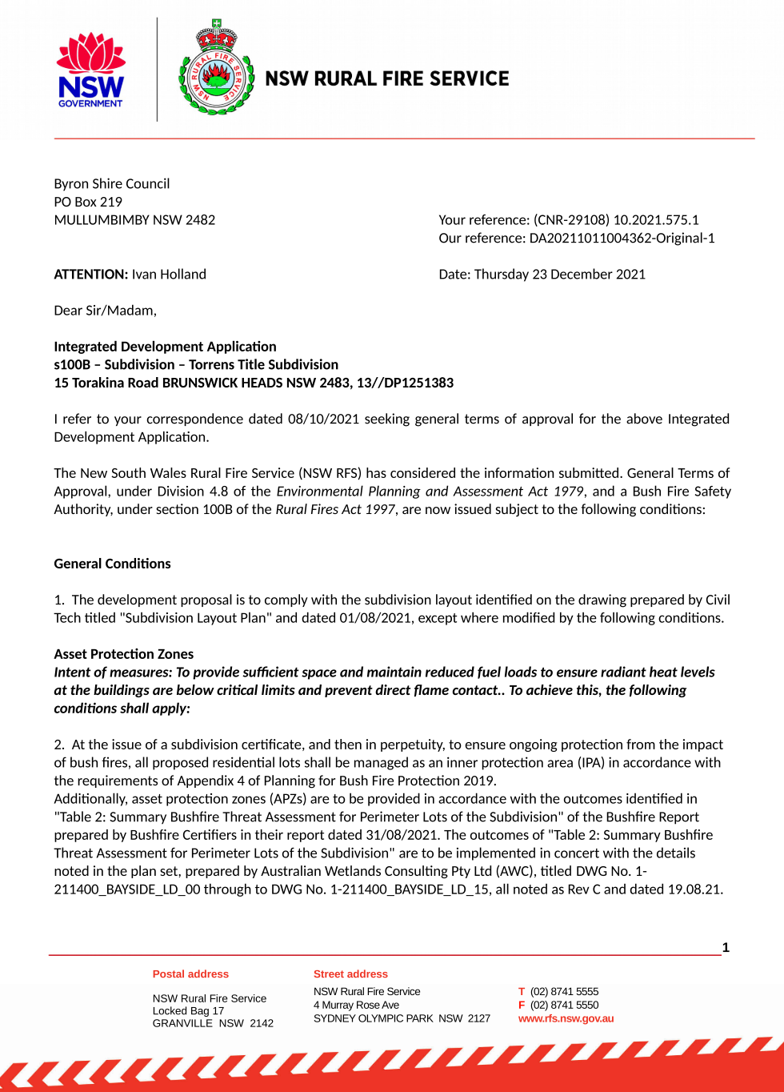

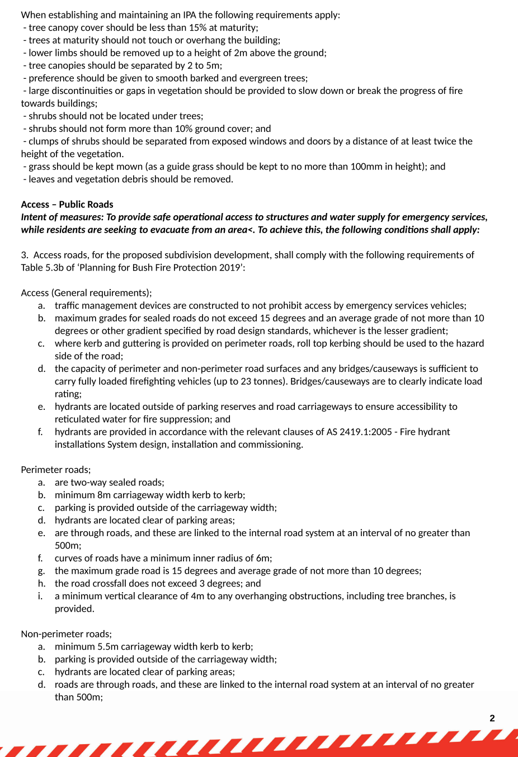
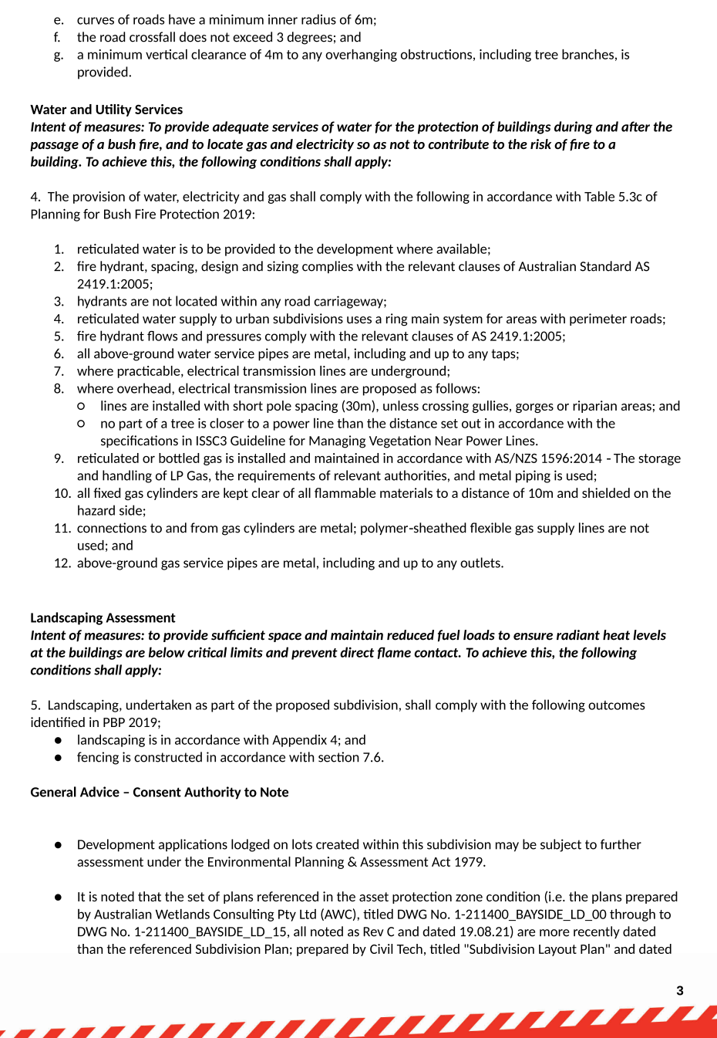

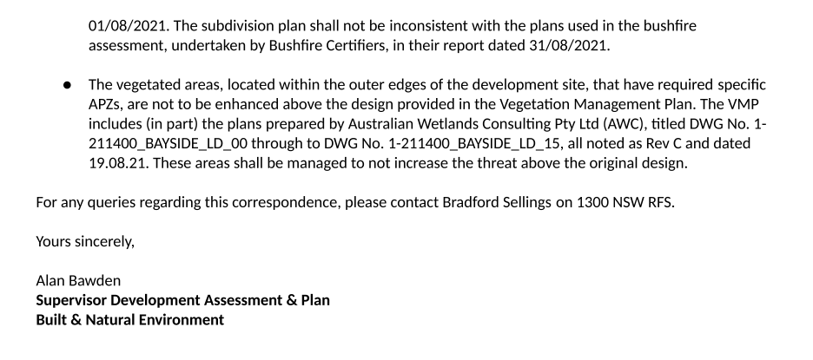
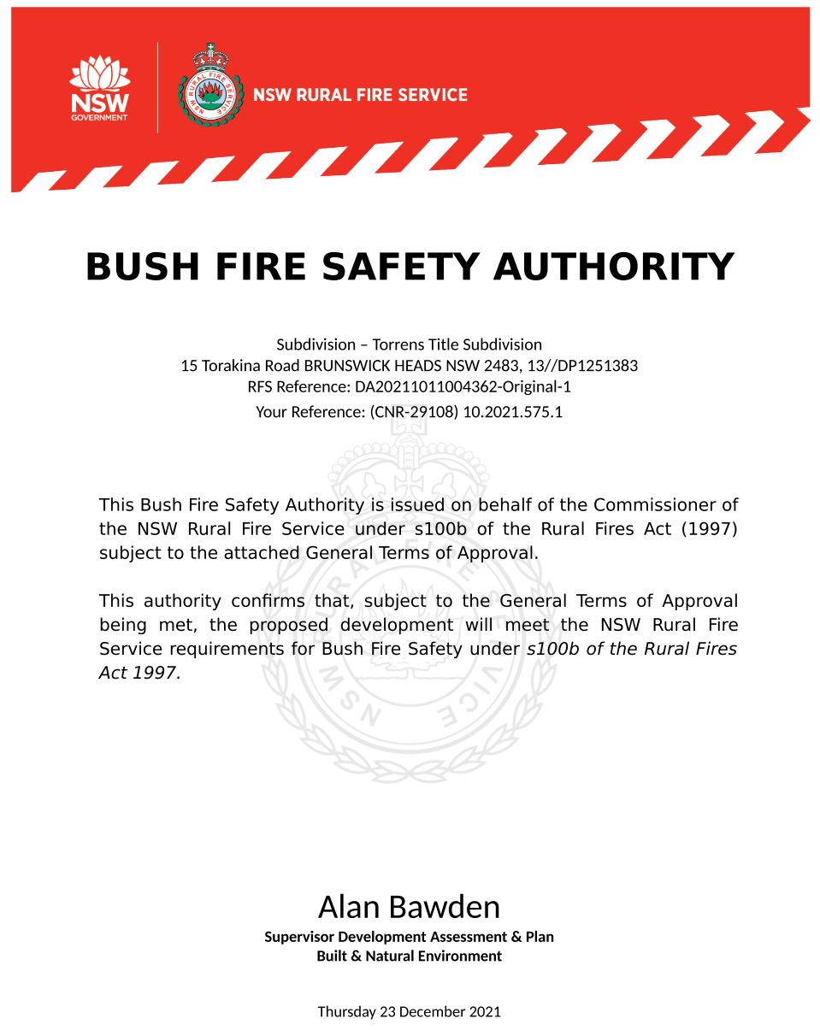

Schedule 2 REASONS FOR DECISION, HOW COMMUNITY VIEWS WERE ADDRESSED
Statement of Reasons
The proposed development complies with the provisions of Byron Local Environmental Plan 1988
The proposed development complies with relevant State Environmental Planning Policies
The proposed development complies with relevant provisions of Development Control Plan 2010
The proposed development complies with Environmental Planning & Assessment Regulation 2021 considerations.
The proposed development will not have significant adverse impact on the natural, built or social environment or economic impacts on the locality.
The proposed development is considered suitable for the proposed site.
The development application was notified/advertised in accordance with Council’s Community Participation Plan. Issues raised in the submissions have been addressed during assessment of the application.
The proposed development is unlikely to prejudice or compromise the public interest.
How community views were addressed
The DA was advertised in accordance with Council’s Community Participation Plan. The submissions received were considered on merit and addressed during assessment of the application.
To view the considerations, please contact Council to view a copy of the assessment report relating to this DA.

Schedule 3 NOTES

Protection of the Environment Operations Act 1997:
It is an offence under the provisions of the Protection of the Environment Operations Act 1997 to act in a manner causing, or likely to cause, harm to the environment. Anyone allowing material to enter a waterway or leaving material where it can be washed off-site may be subject to a penalty infringement notice (“on-the-spot fine”) or prosecution.

WorkCover Authority
All works must be undertaken in accordance with the requirements of the WorkCover Authority.

Principal Certifying Authority:
Work must not commence until the applicant has appointed a Principal Certifying Authority (if the Council is not the PCA);

Relics Provisions- Advice
Attention is directed to the NSW Heritage Act 1977 and the provisions of the Act in relation to the exposure of relics. The Act requires that if:

- a relic is suspected, or there are reasonable grounds to suspect a relic in ground, that is likely to be disturbed damaged or destroyed by excavation; and/or
- any relic is discovered in the course of excavation that will be disturbed, damaged or destroyed by further excavation;

Those responsible for the discovery must notify nominated management personnel who will in turn notify the Heritage Council of New South Wales or its delegate, the Office of Environment and Heritage, NSW Heritage Branch, and suspend work that might have the effect of disturbing, damaging or destroying such relic until the requirements of the NSW Heritage Council have been satisfied (ss139, 146).

Penalties apply for failure to comply with development consents
Failure to comply with conditions of development consent may lead to an on the spot fine being issued pursuant to section 4.2(1) of the Environmental Planning & Assessment Act 1979 or prosecution pursuant to section 9.50 of the Environmental Planning & Assessment Act 1979.

Water payments under the Water Management Act 2000
Charges will be calculated based on the additional water and sewerage load that the proposed development generates, shown in Equivalent Tenements (ET) by the following table:
ADDITIONAL WATER & SEWER LOAD OF DEVELOPMENT
(ET Policy 2018)

Water | 125.00 ET
Bulk Water | 125.00 ET
Sewer | 125.00 ET

Payments will be apportioned based on the number of lots being released at individual stages.

NB: Information regarding Development Servicing charges can be found on the Byron Shire Council website (https://www.byron.nsw.gov.au/Services/Water-sewer/Plumbers-and-developers/Calculate-the-cost-of-an-Equivalent-Tenement#section-3).

These charges will enable you to calculate the total contribution charges payable when you are ready to pay them. Developer charges will be calculated in accordance with the Development Servicing Plan applicable at the date of payment.

S7.11 Schedule of Development Contributions
The following contributions are current at the date of this consent. The contributions payable will be adjusted in accordance with the relevant plan and the amount payable will be calculated on the basis of the contribution rates that are applicable at the time of payment. Payments will be apportioned based on the number of lots being released at individual stages.

The current contribution rates are available from Council offices during office hours. Payments will only be accepted by cash or bank cheque.

Definition of Terms Used in these conditions of consent

ASSMP: Acid Sulfate Soils Management Plan
CEMP: Construction Environmental Management Plan
ESCP: Erosion and Sediment Control Plan
NVMP – Noise and Vibration Management Plan
SGMP: Surface and Groundwater Monitoring Plan
SMP – Stormwater Management Plan
UFP – Unexpected Findings Protocol
VMP - Vegetation Management Plan
WFMP – Wallum Froglet Management Plan
DMP – Dewatering Management Plan

